Microservices Containerization – Local Setup Walkthrough
Verifying that Docker and Docker Compose are installed
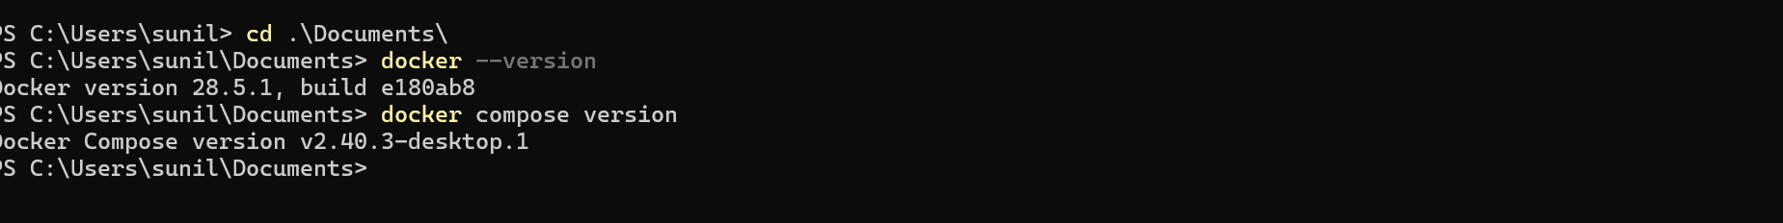
Cloning the repository
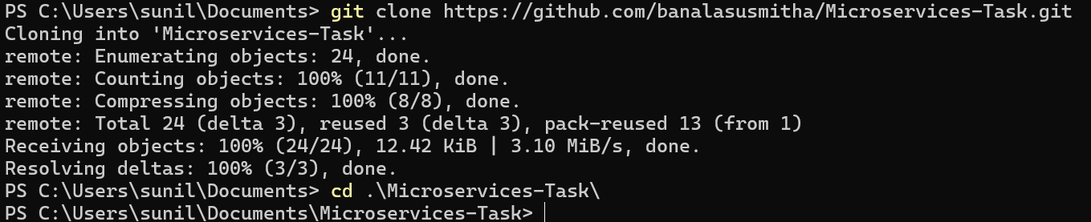
Creating the Dockerfile for each service
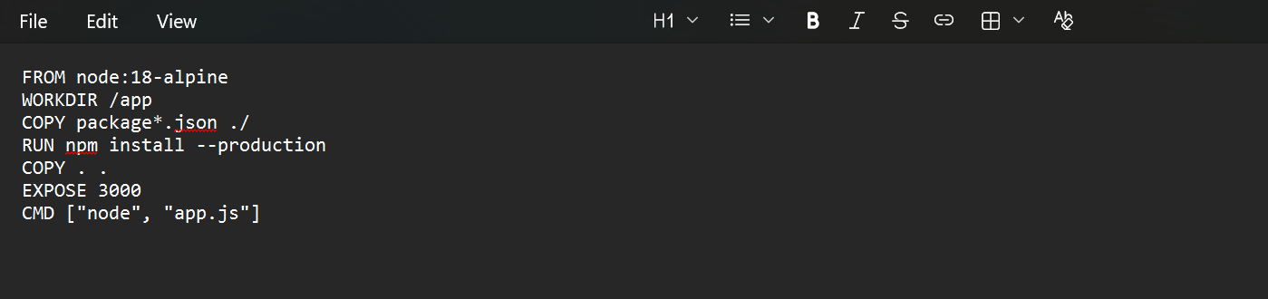
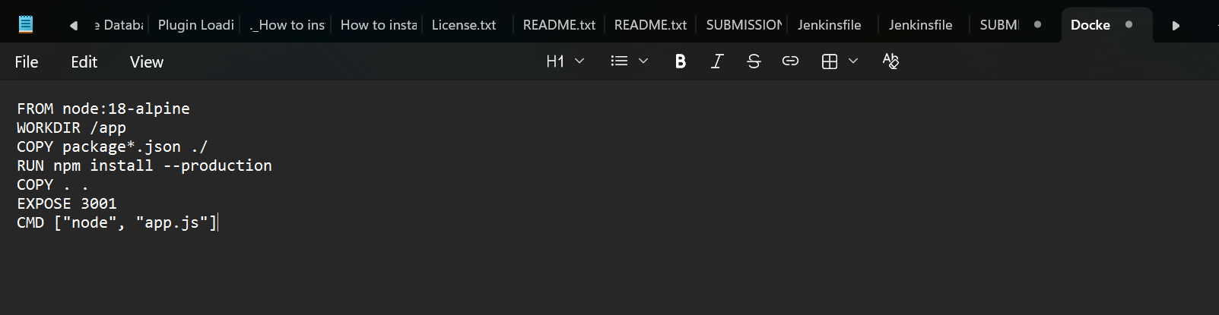
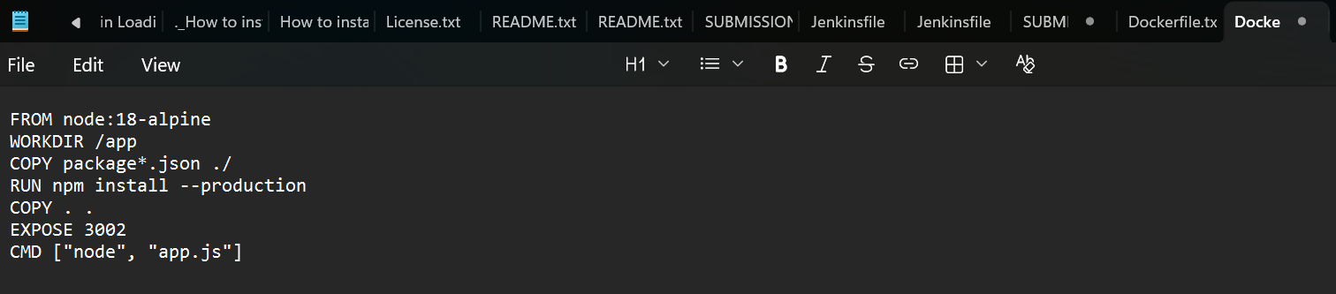
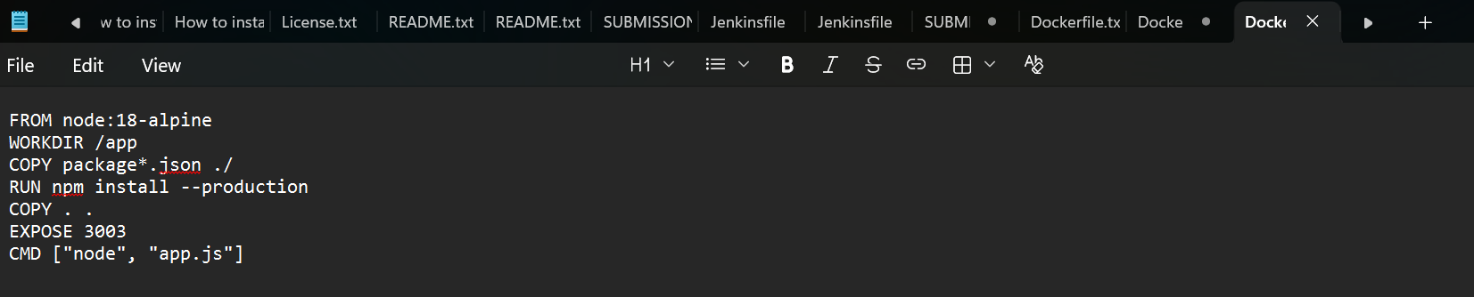
The docker-compose.yml configuration
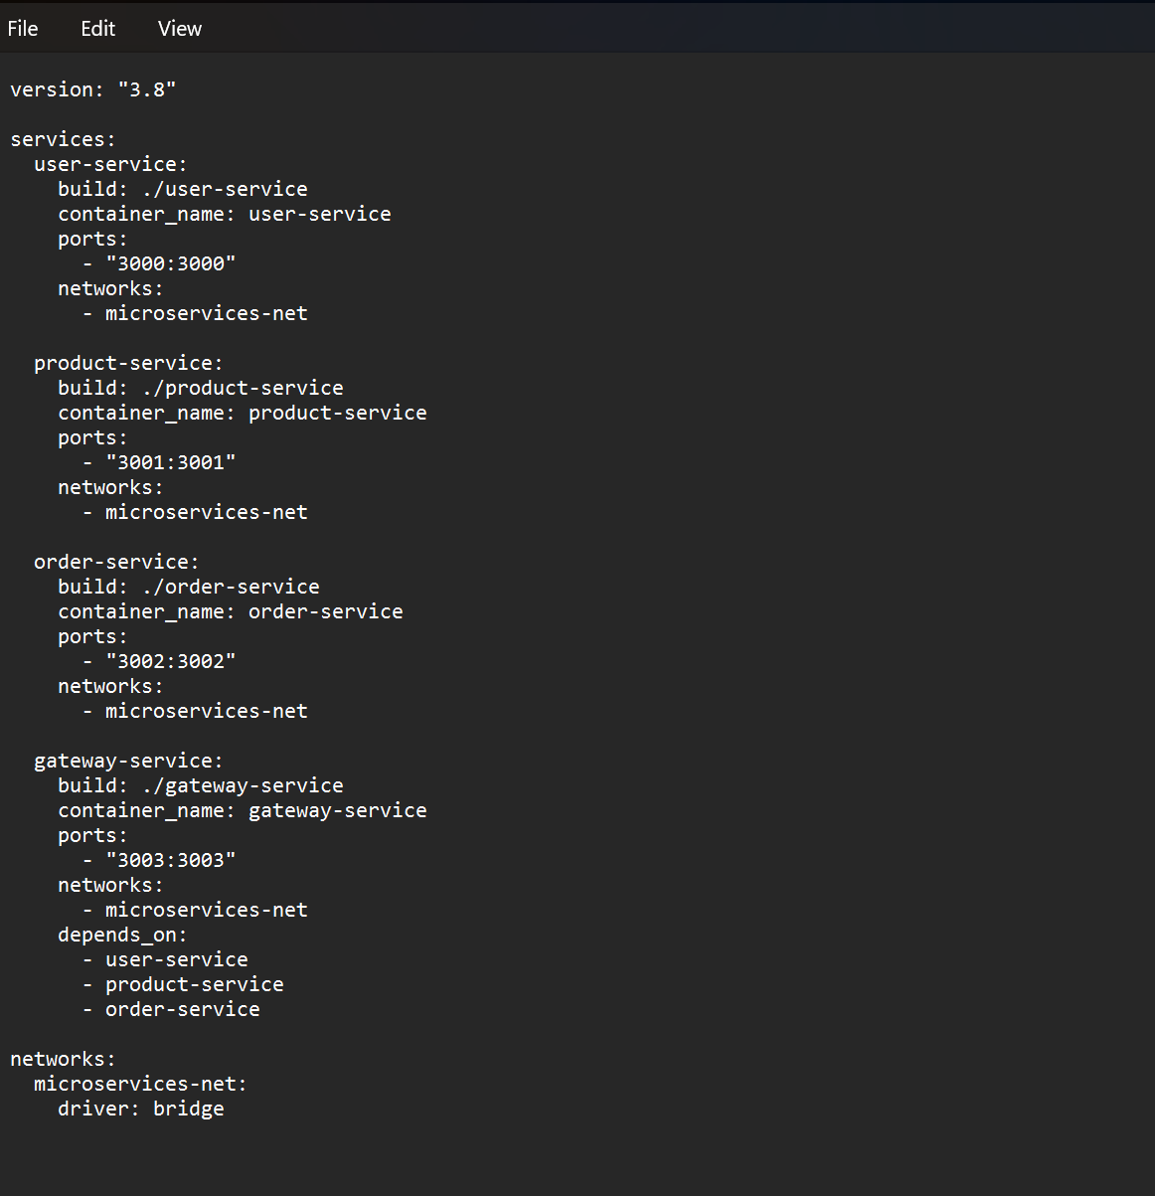
Building and running the services with docker-compose up --build
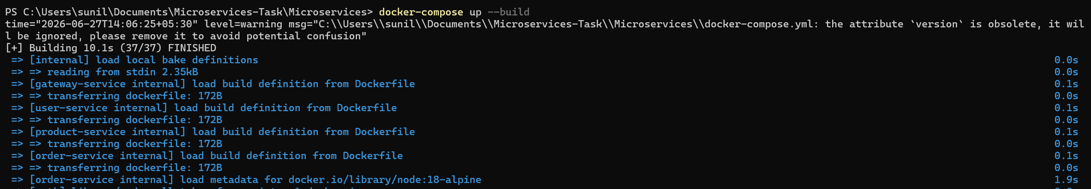
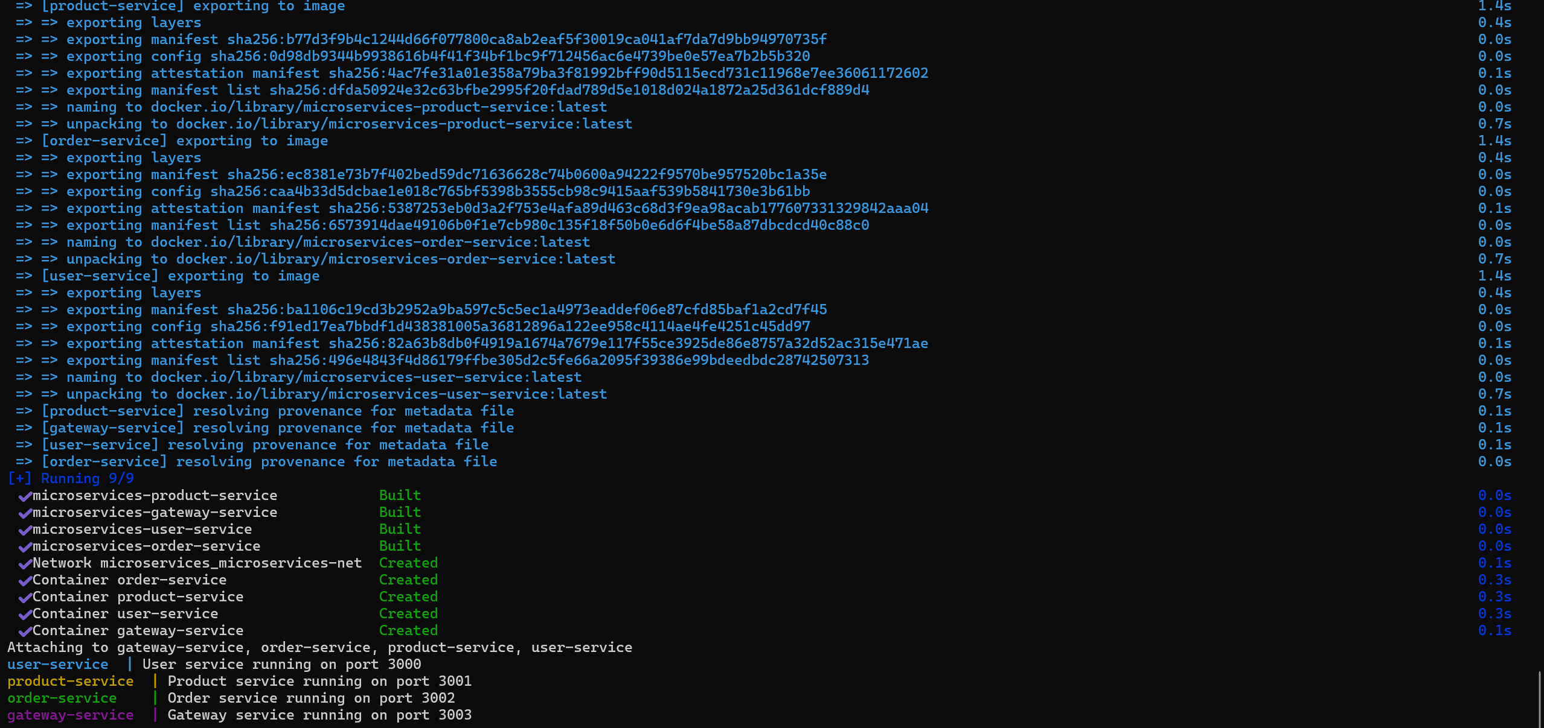
Checking the running containers in another terminal with docker ps
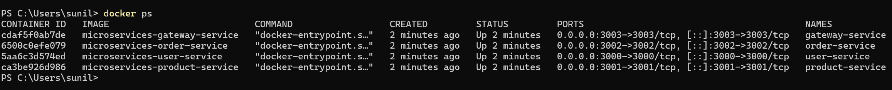
User Service responding at http://localhost:3000/users, returning the list of users in JSON format.
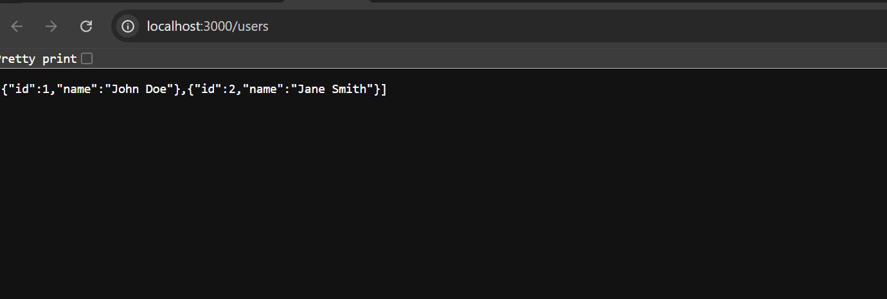
Product Service responding at http://localhost:3001/products, returning the list of products.
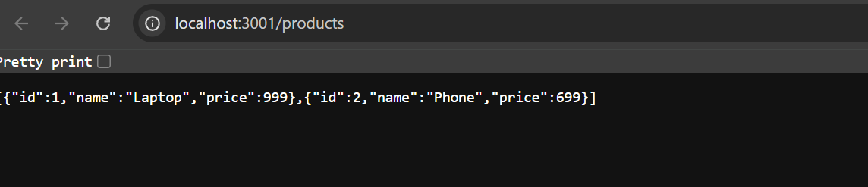
Order Service responding at http://localhost:3002/orders, returning the list of orders.
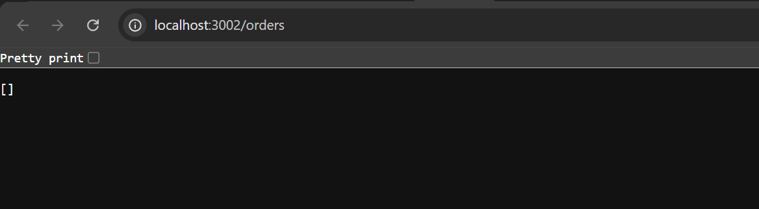
Gateway Service routing requests at http://localhost:3003/api/users, confirming inter-service communication through the gateway.
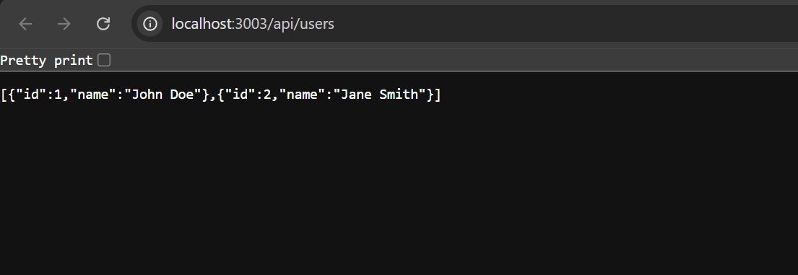
Stopping the services with docker-compose down

